The University Of Azad Jammu & Kashmir

Student Name : Qurat Ul Ain Fatima
Roll No : 2024-SE-05
Course Title : Digital Image Processing
Lab Instructor : Engr. Fahad Nisar
Date Of Submission : 23-October-2026
Department of Software Engineering
Lab Task # 01: Python Setup, Fundamentals, and Implementation

Objective:
The objective of this lab task was to install Python and Visual Studio Code, practice basic Python programming concepts, including variables, data types, conditions, loops, functions, and collections, install the required Python packages, and verify the necessary import statements.

Verify Python and pip Version:
According to your Digital Image Processing Lab Task 01, this screenshot shows Step 2: Verify Python and pip.
Explanation:
In this step, I opened Command Prompt on Windows and executed two commands to verify that Python and pip were installed correctly on my computer.
Commands used:
python --version
This command displays the installed Python version. The output shows Python 3.15.0.
python -m pip --version
This command displays the installed pip version and its installation location. The output shows pip 26.2.1, installed in the Python 3.15 directory.

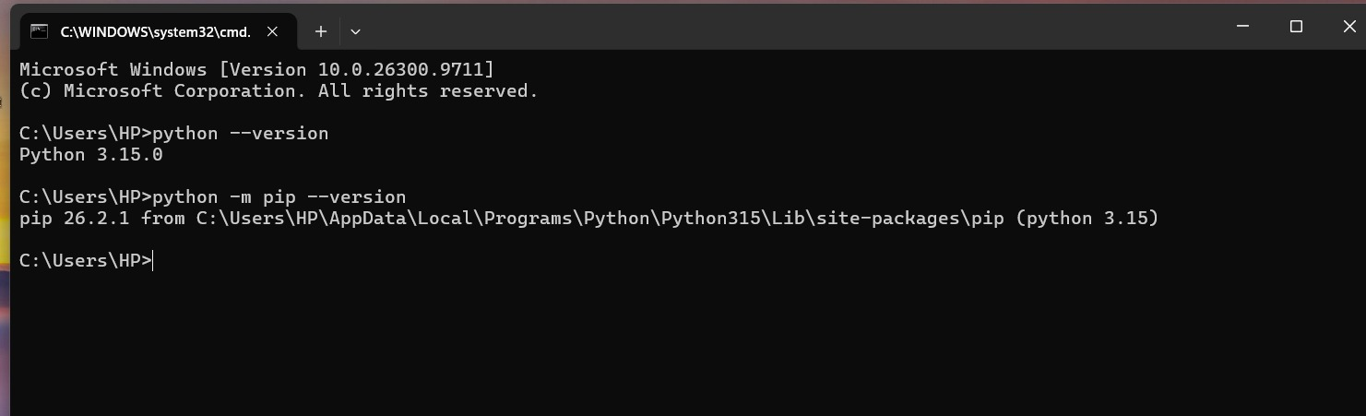

Selecting Python Interpreter in Visual Studio Code:
In this step, I opened Visual Studio Code and accessed the Python extension in the Extensions Marketplace. I searched for Python and located the Python extension provided by Microsoft.
Next, I opened the Select Interpreter menu to choose the Python interpreter installed on my computer.
I selected Python 3.15 (64-bit) from the following path:
~\AppData\Local\Programs\Python\Python315\python.exe
The screenshot also shows a Conda environment named base (3.14.6), but I selected the global Python 3.15 interpreter.
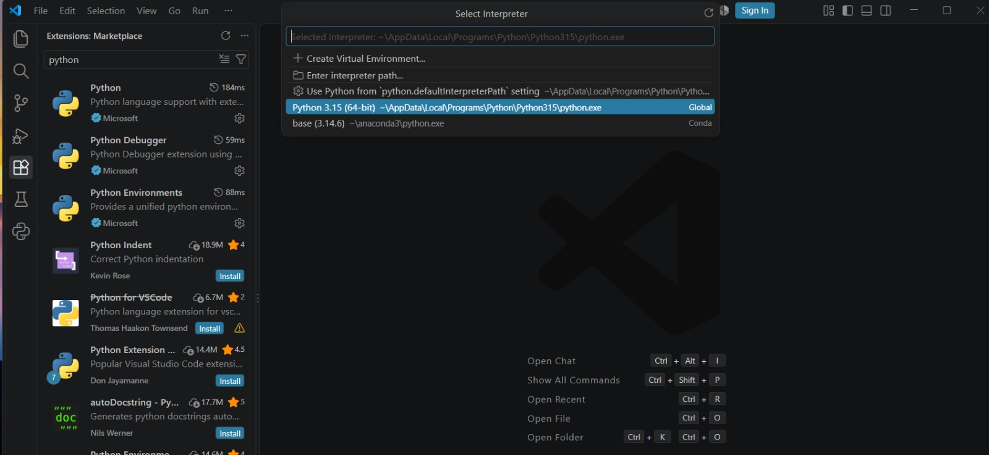
Run the First Python Program:
In this step, I created a Python file named hello.py in Visual Studio Code. I wrote a simple Python program to display a message on the screen.
Code:
# My first python program
print('Hello,Digital Image Processing!')
The first line is a comment that describes the program. The second line uses Python's print() function to display the message.
After saving the file, I executed it in the VS Code terminal using the following commands:
cd "$env:USERPROFILE\Desktop\DIP-Lab_01"
python hello.py
The first command navigates to the project folder, and the second command runs the Python file.
Output:
Hello,Digital Image Processing!
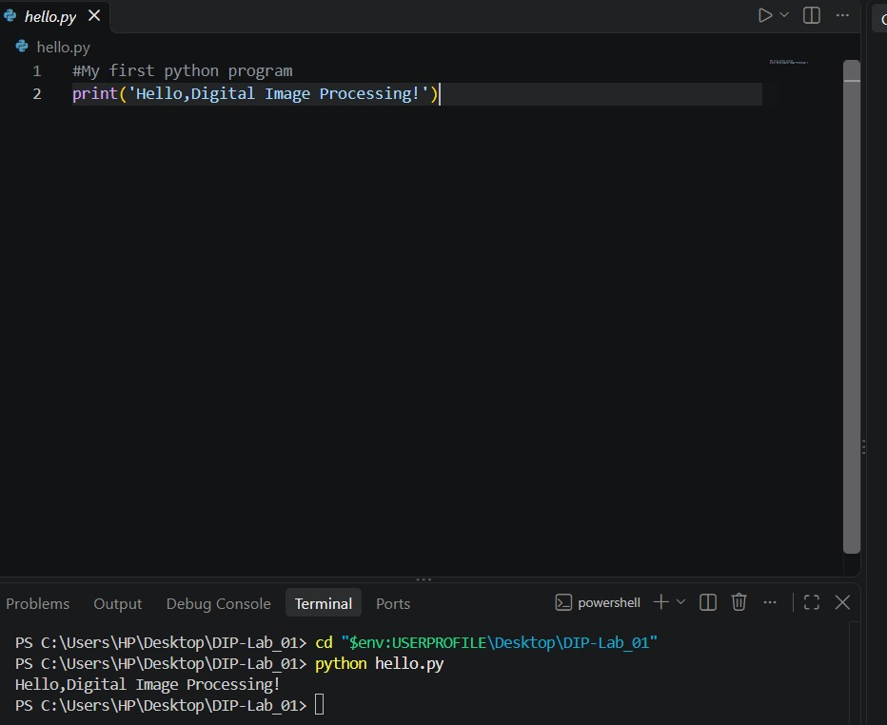

In this step I have successfully run your Python file `basics.py` in Visual Studio Code. It shows the output of Exercise 1: Variables and Data Types.

1. Exercise 1: Variables and Data Types:
I created four variables:
python
width = 640
height = 480
image_name = "sample.png"
is_color = True

| Variable | Value | Data type |
| ---------- | ---------- | -------------- |
| width | 640 | int (integer) |
| height | 480 | int (integer) |
| image_name | sample.png | str (string) |
| is_color | True | bool (Boolean) |

The `type()` function displays the data type of each variable.

2. Calculating total pixels:
python
print("Total pixels:", width * height)
Python multiplied the width by the height:
640 \\times 480 = 307200
Therefore, the output is:
Total pixels: 307200`
This means the image has 307,200 pixels.
3. Exercise 2: Conditions:

I started the second exercise with:
python
intensities = [-1, 0, 127, 128, 255, 256]

These are pixel intensity values. The code checks each value using conditions:
python
if intensity < 0 or intensity > 255:
label = "Invalid"
elif intensity >= 128:
label = "Bright pixel"
else:
label = "Dark pixel"

The expected classifications are:

| Intensity | Result |
| --------- | ------------ |
| -1 | Invalid |
| 0 | Dark pixel |
| 127 | Dark pixel |
| 128 | Bright pixel |
| 255 | Bright pixel |
| 256 | Invalid |

* Invalid: The value is outside the range 0–255.

* Dark pixel: The value is between 0 and 127.

* Bright pixel: The value is between 128 and 255.

4. Why is the output visible in the terminal?

At the bottom of the screenshot, you ran:

powershell
python basics.py

Python executed my file, and the results appeared in the Terminal. The first exercise's output is visible, and the second exercise's code begins above it.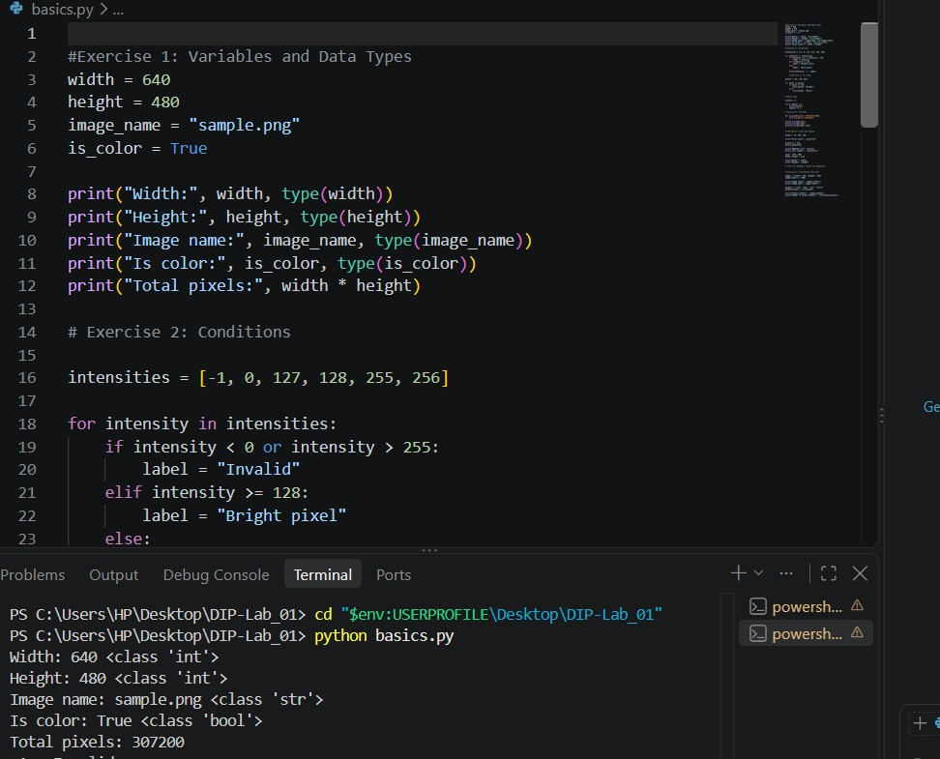

A Python program about conditions (`if`, `else if`, and `else`) was written in VS Code and successfully executed. The output is displayed in the terminal at the bottom.

1. What does the code do?
The program checks pixel intensity values and classifies each value into one of three categories:
* Invalid: The value is less than 0 or greater than 255.
* Bright pixel: The value is 128 or greater, up to 255.
* Dark pixel: The value is between 0 and 127.
2. Explanation of the code:

python
intensities = [-1, 0, 127, 128, 255, 256]
This line creates a list containing six pixel intensity values.
python
for intensity in intensities:
The `for` loop checks each value in the list, one by one.
python
if intensity < 0 or intensity > 255:
label = "Invalid"
If a value is below 0 or above 255, the program labels it as `Invalid`.
python
elif intensity >= 128:
label = "Bright pixel"
If the value is 128 or greater and has not already been classified as invalid, it is a `Bright pixel`.
python
else:
label = "Dark pixel"
If neither previous condition is true, the value is classified as a `Dark pixel`.
Finally:
python
print(intensity, ":", label)
This displays the intensity value and its corresponding label.

3. Output of the program:
-1
Invalid
0
Dark pixel
127
Dark pixel
128
Bright pixel
255
Bright pixel
256
Invalid

4. Why are these values used?
In an 8-bit grayscale image, pixel intensity ranges from 0 to 255:
* 0 represents black.
* 255 represents white.
* Values between them represent different shades of gray.
The program uses 128 as the dividing point between dark and bright pixels.

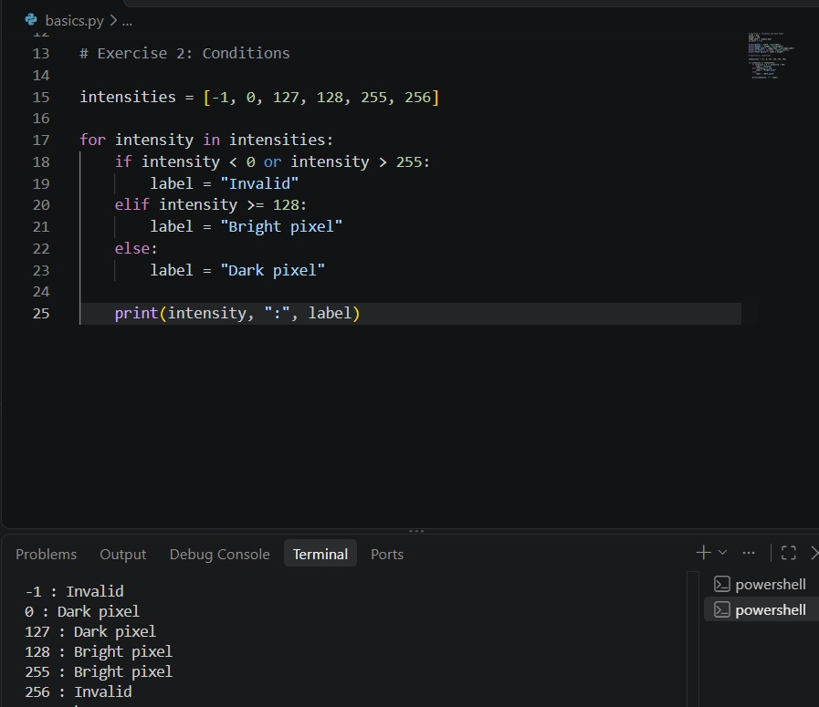

In this step, two types of loops in Python are being used: the `for` loop and the `while` loop. Let's understand them step by step in easy words.

1. For Loop (Lines 29–35)
Code
python
pixels = [20, 130, 255]
for pixel in pixels:
if pixel >= 128
print(pixel, "Bright")
else:
print(pixel, "Dark")

What happened here?
Step 1: A list named `pixels` is created containing three values: `20`, `130`, and `255`.
Step 2: The `for` loop takes one value at a time from the list.
Step 3: The `if` condition checks whether the value is greater than or equal to `128`.
* If the value is 128 or greater, it prints Bright.
* If the value is less than 128, it prints Dark.
Output
text
20 Dark
130 Bright
255 Bright

| Pixel value | Condition | Result |
| ----------- | ----------------------- | ------ |
| 20 | 20 is less than 128 | Dark |
| 130 | 130 is greater than 128 | Bright |
| 255 | 255 is greater than 128 | Bright
The loop repeats the same instructions for every value in the list.

2. While Loop (Lines 38–44)

Code

python
counter = 0

while counter < 3:
print(counter)
counter += 1

What happened here?
Step 1: `counter = 0`
A variable named `counter` is created, and its starting value is zero.
Step 2: `while counter < 3`
Python checks whether the counter is less than 3. If the condition is true, the loop runs.
Step 3: `print(counter)`
It prints the current value of the counter.
Step 4: `counter += 1`
This increases the counter by 1. It is the same as writing:
python
counter = counter + 1
Step-by-step execution

| Loop | Counter value | Is it less than 3? | Printed output |
| ---- | ------------- | ------------------ | -------------- |
| 1 | 0 | True | 0 |
| 2 | 1 | True | 1 |
| 3 | 2 | True | 2 |
| 4 | 3 | False | Nothing |
Output
text
0
1
2

When the counter reaches `3`, the condition `counter < 3` becomes false, so the loop stops.

3. Difference between the two loops

| For loop | While loop |
| ------------------------------------------------------- | ------------------------------------------------------ |
| Used to go through items in a sequence, such as a list. | Used to repeat instructions while a condition is true. |
| Takes values from the list one by one. | Checks the condition before each repetition. |
| Here, it checks three pixel values. | Here, it prints numbers from 0 to 2. |

The terminal displays the output of both programs together: first the pixel results, then the counter values.

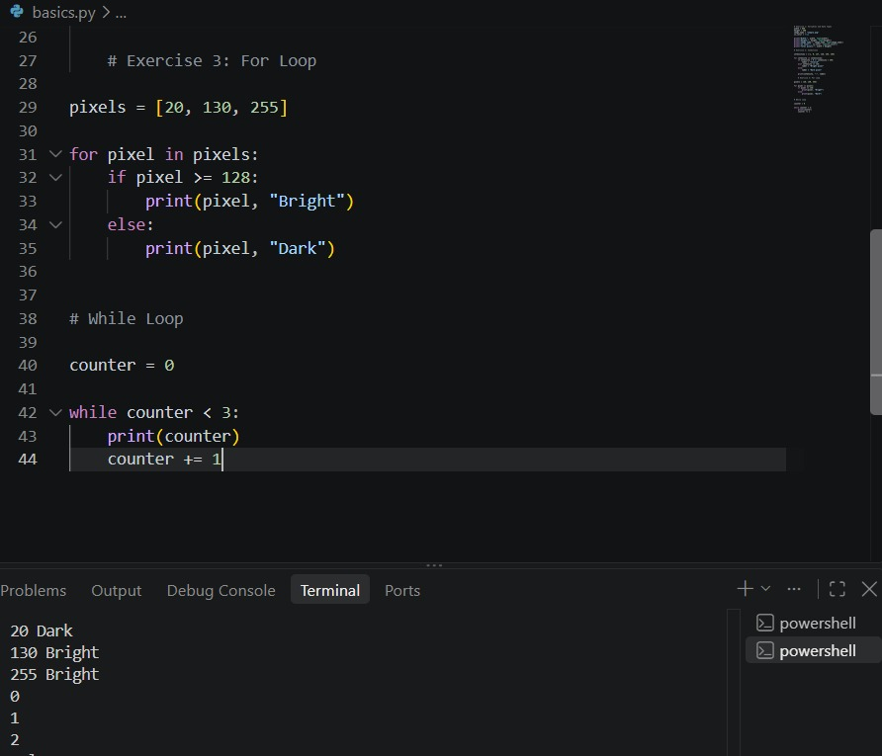
In this image, you are learning two Python concepts: While Loop and Functions. Let's understand them step by step in easy words.

1. While Loop
My code is:
python
counter = 0
while counter < 3:
print(counter)
counter += 1
Explanation:
counter = 0` — starts counting from 0.
while counter < 3:` — repeats the code as long as the counter is less than 3.
print(counter)` — displays the current counter value.
counter += 1` — increases the counter by 1 each time.
Output:
text
0
1
2
How does it work?
| Counter value | Condition (counter < 3) | Result |
| ------------- | ----------------------- | ---------- |
| 0 | True | Prints 0 |
| 1 | True | Prints 1 |
| 2 | True | Prints 2 |
| 3 | False | Loop stops |
The loop stops when the counter reaches 3 because `3 < 3` is false.

2. Function:
My code is:
python
def is_bright(pixel, threshold=128):
return pixel >= threshold
Explanation:

def` — used to create a function.
is_bright` — the function's name.
pixel` — the value given to the function.
threshold=128` — the default threshold value is 128.
return pixel >= threshold` — checks whether the pixel value is greater than or equal to the threshold and returns `True` or `False`.
The function checks whether a pixel is bright enough according to the threshold.
3. Understanding the three function calls:
First call
python
print(is_bright(127))
The pixel is 127, and the default threshold is 128.
Since , the result is `False`.
Second call
python
print(is_bright(128))
The pixel is 128, and the threshold is 128.
Since , the result is `True`.
Third call
python
print(is_bright(200, 210))
Here, I provide two values:
* pixel = 200`
* threshold = 210`
Since , the result is `False`.
4. Final output shown in terminal:

Output
text
False
True
False
* A while loop repeats a block of code while its condition is true.
* A function is a reusable block of code that performs a particular task.
* True means the condition is correct.
* False means the condition is not correct.
The terminal shows the output of the function calls, not the while loop. The loop's output would be `0`, `1`, and `2` if it was executed.
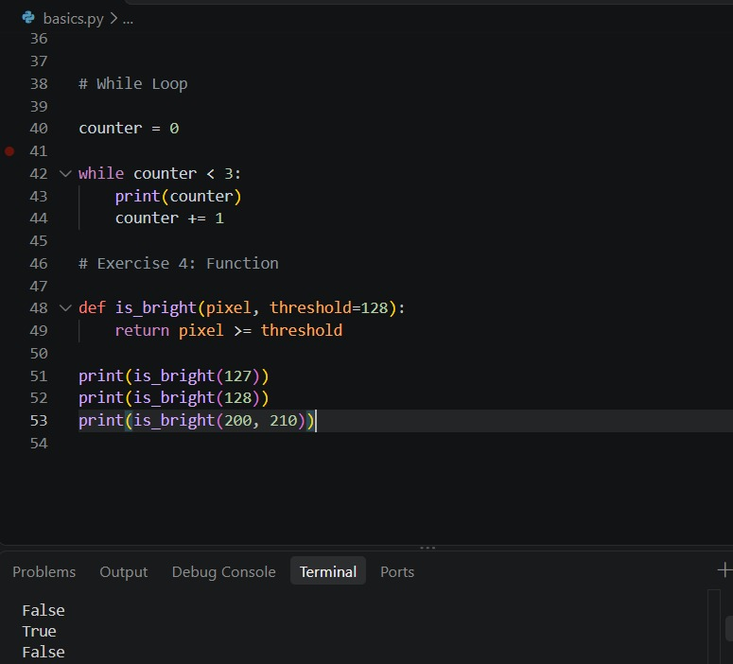

In this step, you are running a Python program in VS Code that demonstrates Lists and Tuples in Python.
1. Creating a list

python
pixels = [0, 128, 255]
A list named `pixels` is created with three values: `0`, `128`, and `255`.

2. Printing the first pixel
python
print("First pixel:", pixels[0])
Python uses index `0` for the first element, so the output is:
text
First pixel: 0

3. Updating and adding an element
python
pixels[1] = 150
pixels.append(64)
* pixels[1] = 150` changes the second element from `128` to `150`.
* pixels.append(64)` adds `64` to the end of the list.
The updated list becomes:
text
[0, 150, 255, 64]

4. Finding the list length
python
print("Updated list:", pixels)
print("List length:", len(pixels))
The output is:
text
Updated list: [0, 150, 255, 64]
List length: 4
The list contains four elements, so `len(pixels)` returns `4`.
5. Creating a tuple
python
size = (640, 480)
width, height = size
Here, a tuple stores two values:

* `640` represents the width.
* `480` represents the height.
Python assigns these values to the variables `width` and `height`.
The output is:
text
Width: 640
Height: 480
6. Difference between lists and tuples
The final comment in your code explains:
python
# Lists are mutable; tuples are immutable.`
* List: Mutable, meaning you can change its elements, add new elements, or remove elements.
* Tuple: Immutable, meaning you cannot change its elements after creating it.
Final output

text
False
First pixel: 0
Updated list: [0, 150, 255, 64]
List length: 4
Width: 640
Height: 480

Lists and Tuples program is working correctly, and the terminal is displaying the results of Python code.

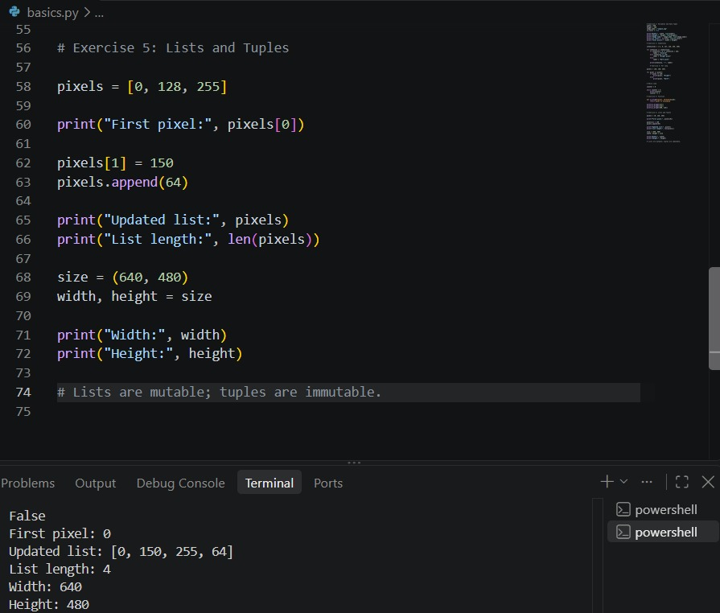
In this code, I have learned Dictionaries and Sets in Python. code ran successfully, and the output is correct.
1. Dictionary in Python
code:
python
image = {"width": 640, "height": 480}
image["mode"] = "RGB"
What happened?
* `image` is a dictionary that stores data in key-value pairs.
* `"width": 640` means the image width is 640 pixels.
* `"height": 480` means the image height is 480 pixels.
* `image["mode"] = "RGB"` adds a new key called `mode` with the value `"RGB"`.

Then I printed:
python
print("Image width:", image["width"])
print("Image mode:", image["mode"])

Output:
text
Image width: 640
Image mode: RGB
This shows that Python successfully retrieved the values from the dictionary.

2. Set in Python
code:
python
animals = ["cat", "dog", "cat", "bird"]
unique_animals = set(animals)
What happened?
* `animals` is a list containing four items.
* `"cat"` appears twice.
* `set(animals)` converts the list into a set.
* A set automatically removes duplicate values.
Original list
cat

dog
cat
bird
Convert using `set()`
Unique animals (duplicates removed)
cat
dog
bird
3. Counting unique animals
code:
python
print("Unique animals:", unique_animals)
print("Number of unique animals:", len(unique_animals))
Output:
text
Unique animals: {'bird', 'cat', 'dog'}
Number of unique animals: 3
* `unique_animals` displays the three unique animals.
* `len(unique_animals)` counts how many unique items are in the set.
* The answer is 3 because `cat` is counted only once.
The order of items in a set may change. output can display the animals in a different order, and that is normal.
4. What about the output above these lines?
The terminal also shows earlier results:
text
False
First pixel: 0
Updated list: [0, 150, 255, 64]
List length: 4
Width: 640
Height: 480
These are outputs from earlier exercises in Python file. They show results from previous operations, such as checking a condition, accessing a list item, updating a list, and printing dimensions.
Remember these three important points
* Dictionary (`dict`) stores information as key-value pairs.
* Set (`set`) stores unique items and removes duplicates.
* `len()` counts the number of items.

Exercise 6 is working correctly!
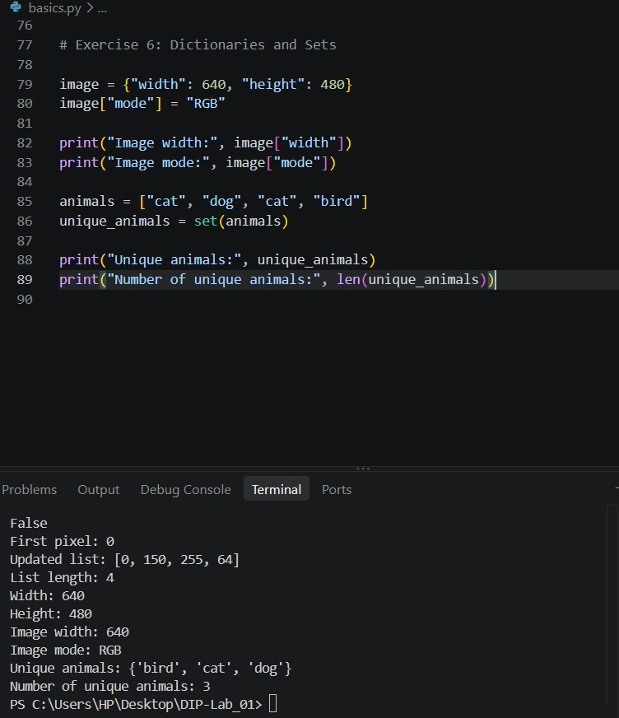
In this Step, I am using Visual Studio Code (VS Code) Terminal, and Python showing information about an installed library.

What happened here?

* Python library information: The terminal is displaying details about a library, most likely `matplotlib`, which is used to create graphs and charts in Python.
* Location: `C:\Users\HP\AppData\Local\Programs\Python\Python315\Lib\site-packages`
This is the folder where Python libraries are installed on your computer.
* Requires: The listed names, such as `numpy`, `pillow`, and `cycler`, are other libraries that this package depends on.
* Required-by: This shows which other installed packages depend on the library. Nothing is listed here.
* Terminal prompt: `PS C:\Users\HP\Desktop\DIP-Lab_01>`
This means the terminal has finished the previous command and is ready for you to enter another one.
Is there an error?
No error is visible in this screenshot. It looks like Python has displayed package information successfully.

What should we do next?
If I want to check whether Matplotlib works, I will type this command in the terminal:
bash
python -c "import matplotlib.pyplot as plt; print('Matplotlib is working!')"
Press Enter. If it prints `Matplotlib is working!`, the library is installed and can be imported successfully.

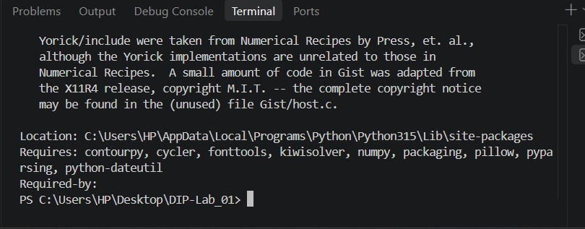
In this step, I have successfully run Python file in VS Code, and no error is visible.

1. What does the code do?
file `lab01_imports.py` contains three import statements:
python
import numpy as np
from PIL import Image
import matplotlib.pyplot as plt
* Line 1 — NumPy: Imports NumPy for numerical calculations and arrays. `np` is its short name.
* Line 2 — PIL Image: Imports the `Image` module to open, edit, and process images.
* Line 3 — Matplotlib: Imports `pyplot` for creating graphs and displaying visualizations. `plt` is its short name.

2. What happened in the terminal?
At the bottom of your screen, you ran:
powershell
python lab01_imports.py
The terminal returned to the prompt without displaying an error.
This means the script appears to have executed successfully. Python imported the libraries, assuming they are installed in your selected Python environment.

Why is there no output?
Because code only imports libraries. It does not print anything or display an image or graph.
3. What should you do next?
To test code, add these lines at the bottom:
python
print("All libraries imported successfully!")
Then save the file and run it again.
Expected output:
text
All libraries imported successfully
